MODULE 1 QUES 1
https://www.hackerearth.com/practice/basic-programming/input-output/basics-of-input-output/practice-problems/algorithm/io-exercise/
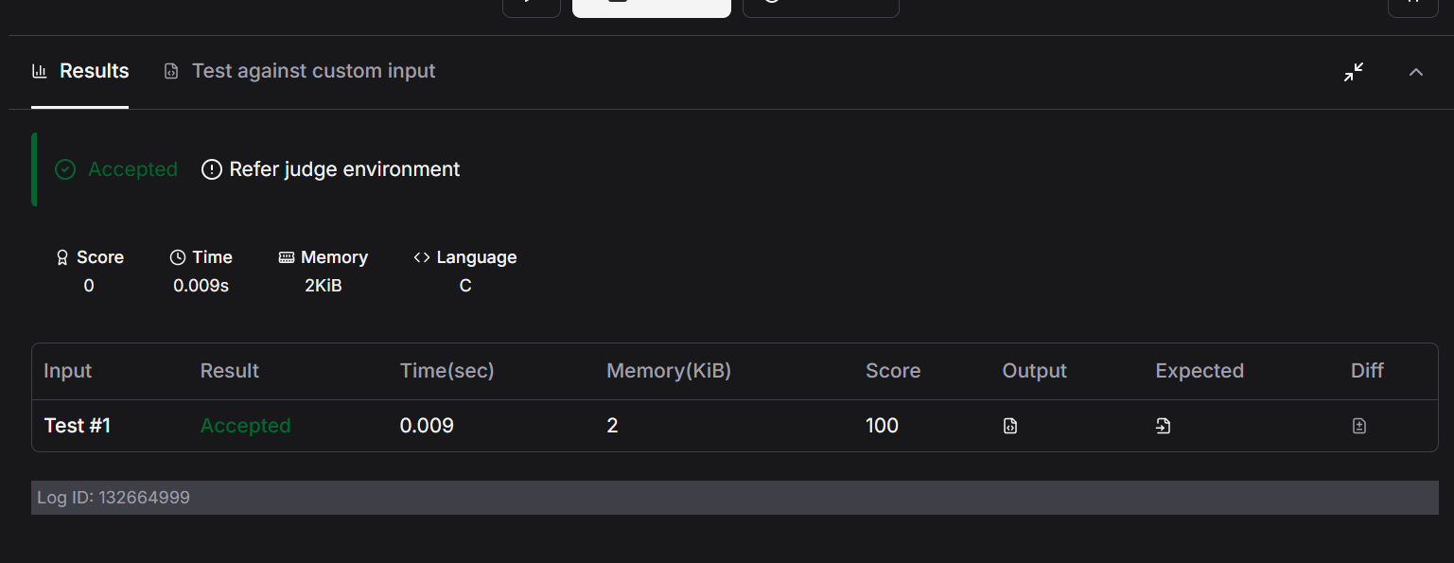
CODE
#include <stdio.h>
int main()
{
int num;
char word[100];
scanf("%d", &num);
num=num*2;
printf("%d\n", num);
scanf("%s",word);
printf("%s\n",word);
return 0;
}

